**Experiment No.4**

**Program1:**

// Constructor Overloading Code

public class A1

{

A1()

{

System.out.println("Constructor without arguments");

}

A1(int a)

{

System.out.println("Constructor with arguments");

}

public static void main(String[] args)

{

A1 obj=new A1();

A1 obj1=new A1(10);

}

}

**OUTPUT:**

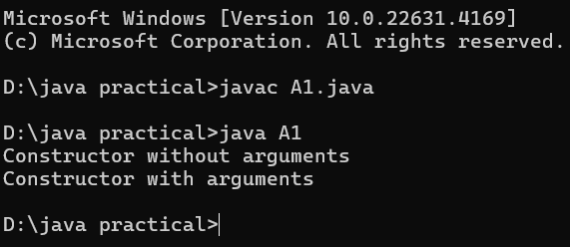

**Program2:**

//Method overloading code

public class A1{

void add()

{

int a=10,b=20;

int c=a+b;

System.out.println("Sum="+c);

}

void add(int x,int y){

int z=x+y;

System.out.println("Sum="+z);

}

public static void main(String[] args){

A1 obj= new A1();

obj.add();

obj.add(40,50);

}

}

**OUTPUT :**

